User Operating Instructions

This document contains the user operating instructions to quickly get started with this program.

1. Login – Enter username and password to login to the web application

Macintosh HD:Users:sstahle:Dropbox:Screenshots:Screenshot 2016-05-04 13.13.11.png

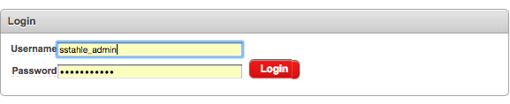

1. Navigating – From the Home page, you can get to all possible screens in the application.

When on any screen, you may get back to the home page by clicking the Volunteers International Logo at the top of the screen.



1. Usability – When on any Interactive Report screen, you may manipulate the data in many different ways by clicking on the *Action* button.

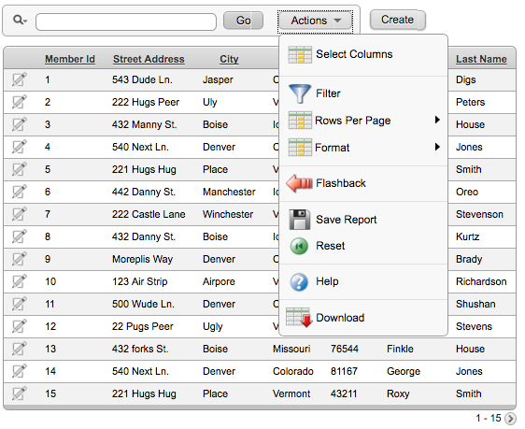

1. Logout – At any time you wish to logout, point to the top right corner of any screen and click *logout*.

Macintosh HD:Users:sstahle:Dropbox:Screenshots:Screenshot 2016-05-04 13.16.29.png